***The supplemental guide***

**“Basic attention for frequency calibration”(Pre-draft)**

**Preamble**

This supplemental guide provides the information about the effective degrees of freedom “” and confidence level. Number of times for measurements “N” is a key parameter to obtain a sufficient . The appropriate value is shown for obtaining about a 95% probability with *k*=2. It is also important to take attention about characteristics of oscillators in the Time and Frequency field.

**1. Background**

The relation between confidence level and degrees of freedom is clearly obtained by using the *t*-distribution with a coverage factor *k*. It can be seen in tables in some guidelines. However, it seems no direct guidance about appropriate effective degrees of freedom to get “confidence level of approximately 95%”. This supplement gives the consideration and practical solution on this　matter.

**2. Discussion points**

It is important to evaluate the effective degrees of freedom in every case, however, relying excessively on it is not sometimes appropriate. Equation (1) is the Welch-Satterthwaite formula,



(1)

where and are the degrees of freedom for Type A and B, respectively. So large  can be easily obtained by supposing that the degrees of freedom for Type B is infinity. For Type A, large  can also be obtained by increasing the division number of data for time interval measurement as an example. We have to also consider characteristics of oscillators which show Flicker FM or Random Walk FM in the long term as shown in Fig.1. Cristal oscillators often show the random walk in the short term as shown in Fig.2, therefor these characteristics have to be considered in calibration method.

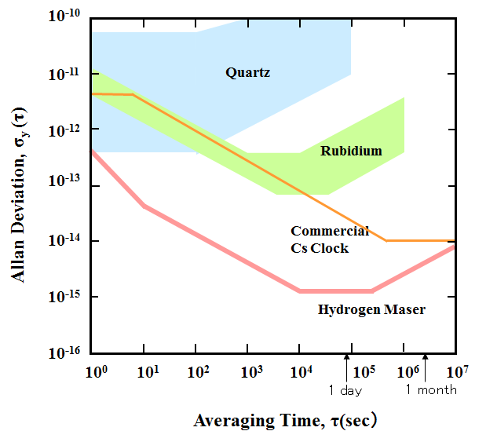

Figure.1. Typical stability for various types of oscillators.

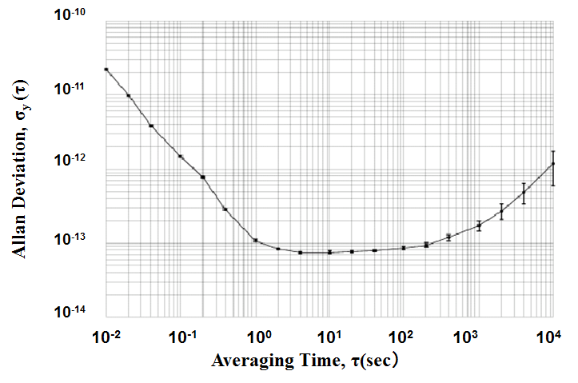

Figure.2. An example stability of crystal oscillator.

**3. Required condition**

It is required to examine the effective degrees of freedom in calculating uncertainty. If the final value is greater or equal to 9,

 (2)

then it is sufficient to obtain about 95% confidence level with expanded uncertainty. The expanded uncertainty is obtained by multiplying coverage factor *k*=2 to the combined standard uncertainty. This expanded value shows about a 95 % probability if the probability density function is the normal distribution. If the  is less than 9 or the probability density function is not normal, value of the coverage factor *k* should be examined in detail.

**4. Example method for frequency calibration**

Figure 3 shows a schematic diagram for frequency calibration. The frequency data are obtained by a frequency counter or a time interval counter. A calibration period is one day for example. The calibration value is the average for all data in the calibration period. The relative frequency for nominal value is obtained from the difference between initial and final phases divided by the calibration period if the time interval measurement is used. We need to calculate the experimental standard deviation from data obtained in the calibration period. Black circles in Fig.3 show average for each interval equally divided by ten. That is the number of times for measurements “N”=10. If N=10 is selected, then it always makes sure that .

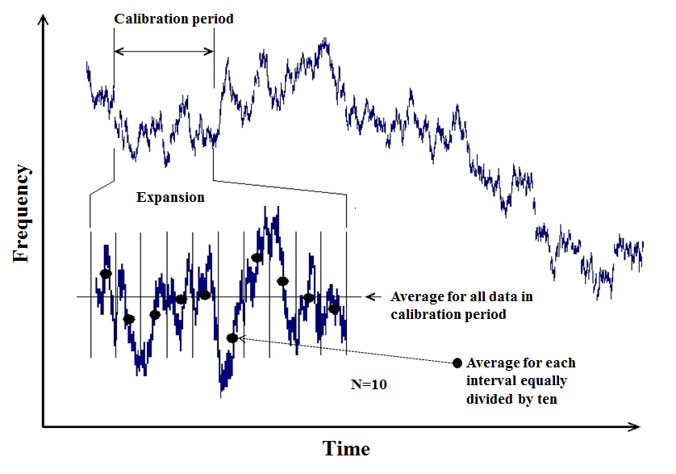

Figure.3. A method of frequency calibration.

**5. Treatment of calibration value**

As already described above, DUT in the Time and Frequency field shows time fluctuation. Moreover, frequency changes by other many reasons with time. Therefore, it is practical that calibration value and its uncertainty are considered as initial values.

(1) Initial value of uncertainty：*ｕ*initial

The other contributing factors have to be counted as additional uncertainty at each calibration laboratory. The assumed causes are listed below.

(2) Long term fluctuation or aging

(3) Reproducibility against power ON and OFF

(3) Dependency for environmental temperature or humidity

(4) Dependency for magnetic field

(5) Dependency for power voltage.